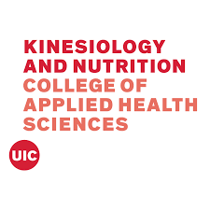
1919 West Taylor, Room 650 (MC 517)
Chicago, Illinois 60612-7256

Prerequisite Form for Nutrition Programs

Name:

Prerequisite completion summary (listing a course on this summary does not guarantee that it satisfies the prerequisite):

Courses already completed |  |  |  |  | Courses to be taken
Prerequisite | School at which course was taken | Course number | Term | Grade/#Credit hours | School planning to attend | Term
English Comp I

English Comp II

General Bio I w/ Lab ^{1,2}

Anatomy and
Physiology I w/ lab^{1,2}
Anatomy and
Physiology II w/ lab^{1,2}
Chem I w/ Lab (inorganic) ^{1,2}
Organic Chem (no lab)^{1,2}
(not a survey course)
Biochemistry ^{1,2}
(not a survey course)
Foods w/ Lab

Nutrition

Algebra

Speech

Intro Psychology

Intro Sociology

¹ Science courses must be taken within five years of applying to the nutrition programs.
² At least 3 of these six courses must be completed at the time of application.
Please note that only grades of “C” and above will be accepted.

Updated 7/2024

